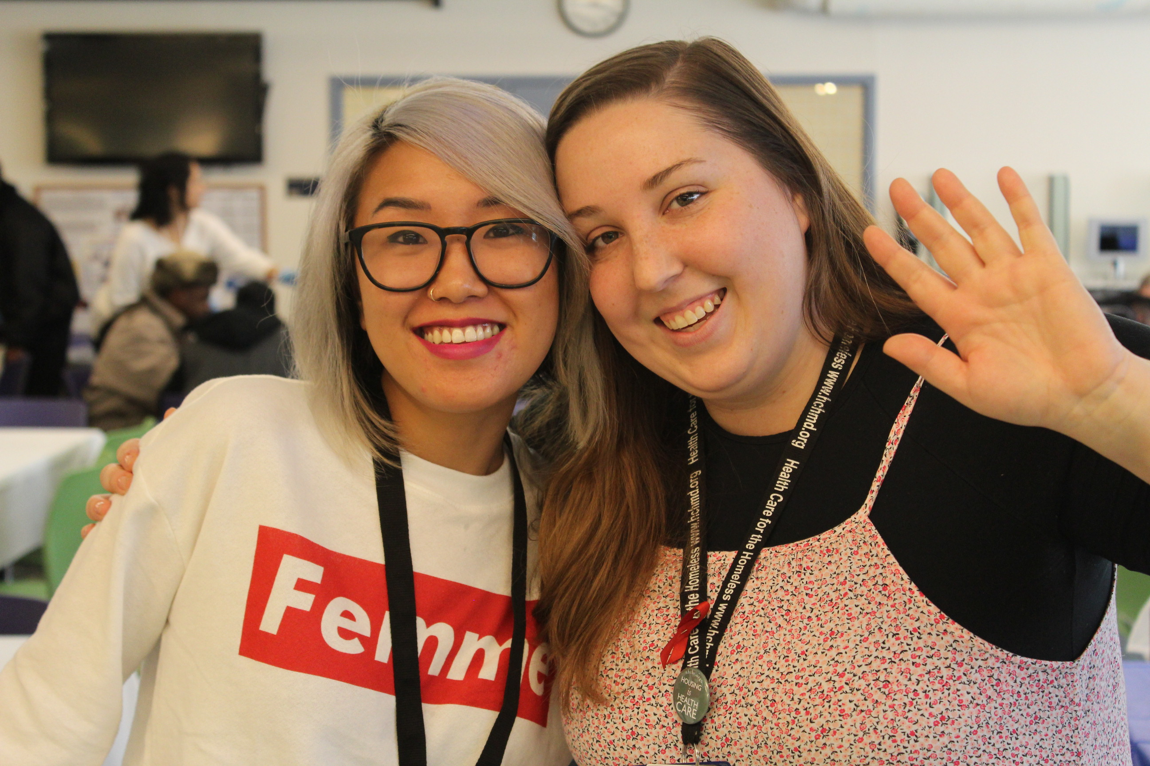

**How to Apply for Disability Group**

**Wednesdays, 11-12 p.m.**

**Third Floor Group Room - A**

Want to learn more about the benefits process?

Not sure if you qualify?

Tired of being denied disability benefits?

*If you answered yes—join us to learn more!*

**Is our New Client Group Right for You?**